# Homework #6: User Management

|  |
| --- |
| * This is an individual assignment, and is worth 20 points. * The due date is Saturday, March 10th, Midnight. * You need to provide your answers to the “Homework #6 - Tasks.docx” file. Change the file name following the naming convention suggested below. * Naming convention is as follows: homework, underscore, last name, first initial, and extension (e.g., Homework #6_ImG.docx). If you do not follow the convention, I will deduct 1. * Do not copy any of the sample screenshots provided as illustrations. * The database for the assignment - AdventureWorks2016CTP3 – in installed on our CWE server. So, using our CWE server will be convent. You should download this document after you login to the server. * You should answer the questions in blue. * You will get deductions if the requested screenshots are not provided. |

# Task #4. Assigning User Mappings to Fixed Database Roles

## A. Assigning a user to a database role

## B. Verifying the results

5) Does it fail? Show the result in a screenshot. Describe your observation and explain why it fails.

**Yes it fails because TestUser-A is apart of the deny_datawriter role.**

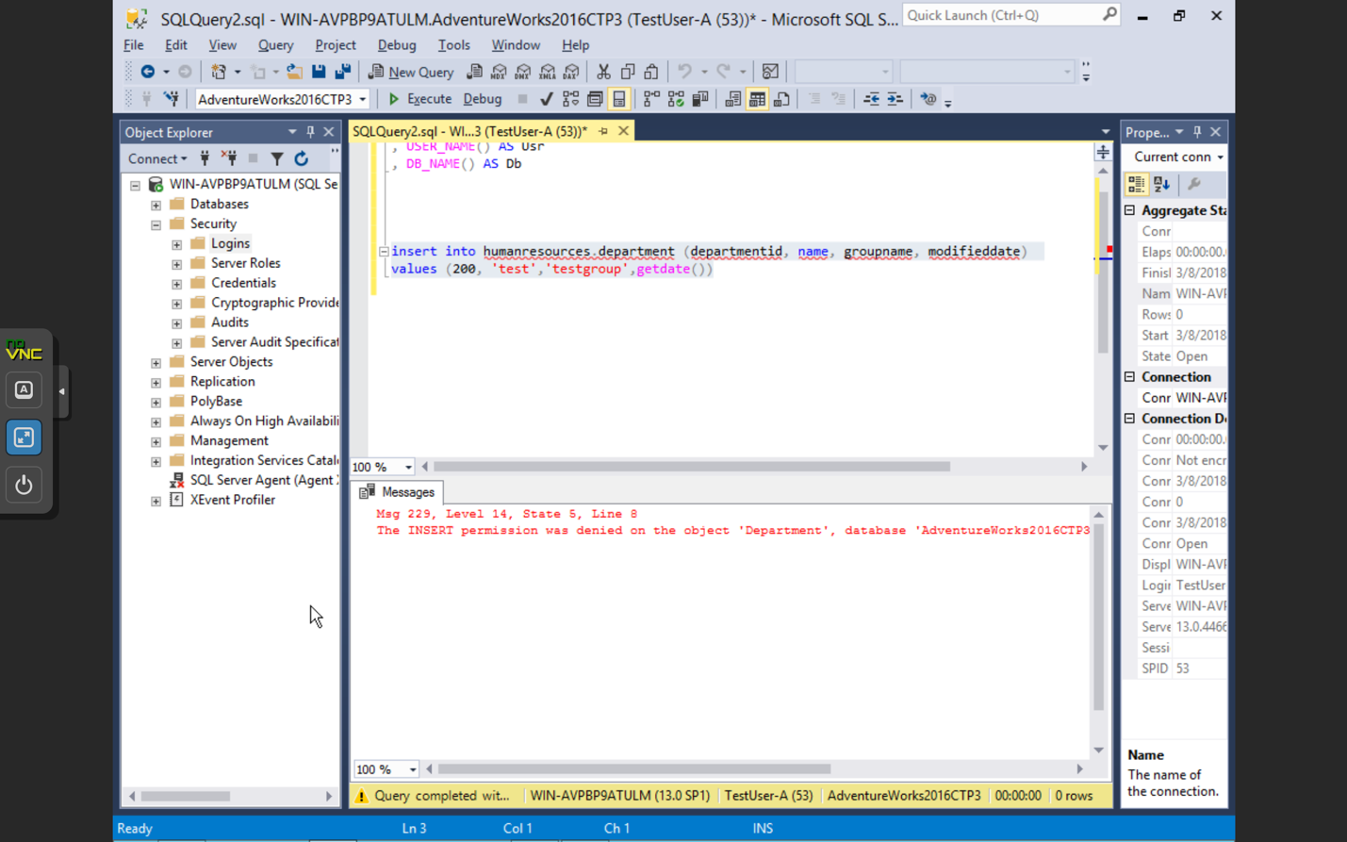

10) Does it fail? Show the result in a screenshot. Describe your observation and explain why it fails.

**Yes it fails because TestUser-B is apart of the deny_datareader role.**

# 

# Task #5. Creating a Custom Database Role

## A. Creating a custom database role

## B. Verifying results

4) Does it work? Show the result in a screenshot. Describe your observation and explain why it works.

**Yes it works because TestUser-C was granted permissions to run select statements on the humanresources.department table.**

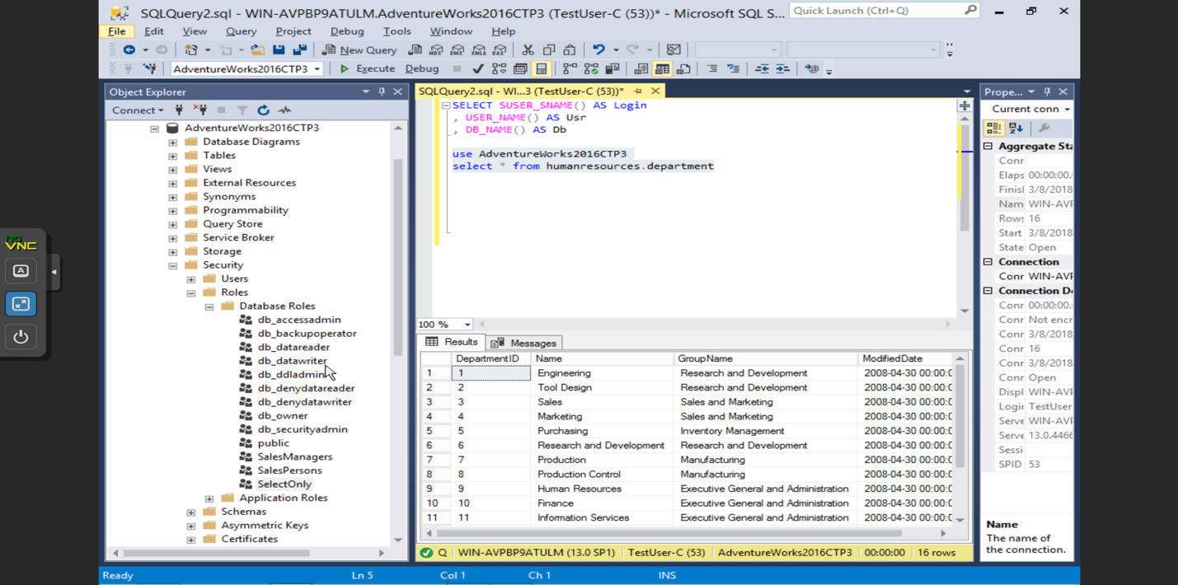

5) Does it fail? Show the result in a screenshot. Describe your observation and explain why it fails.

**Yes it fails because TestUser-C is not granted permissions to insert.**

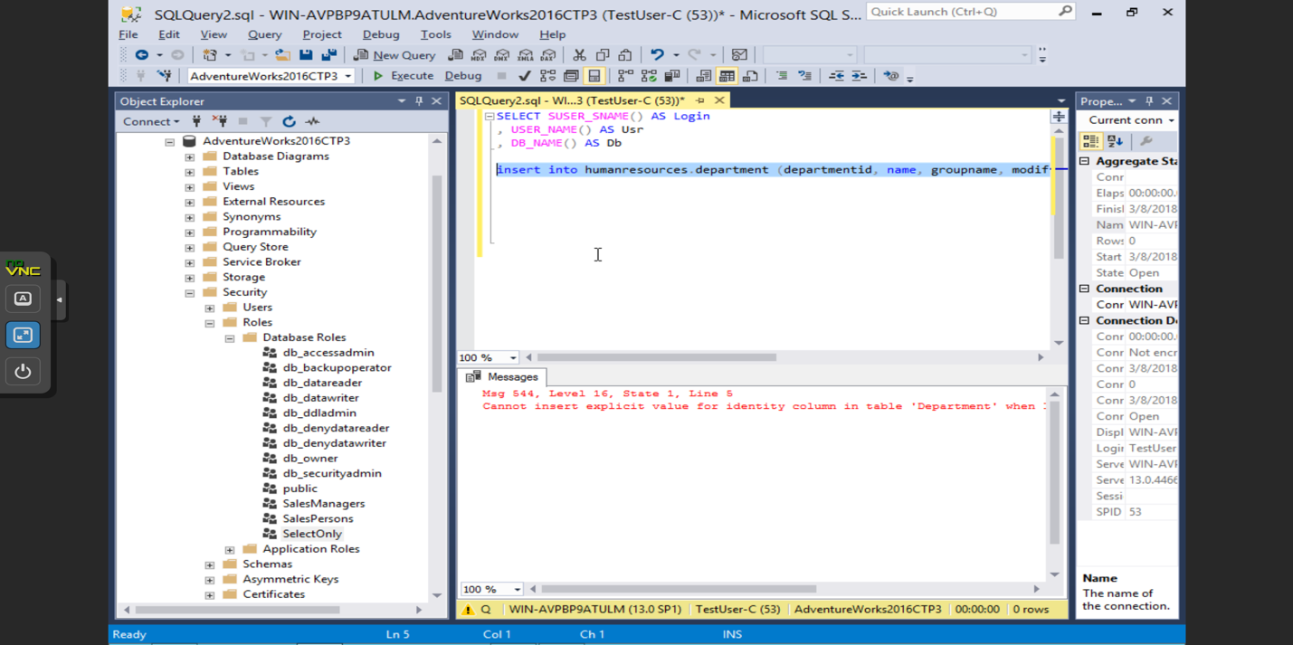

# Task #6. Creating an Application Role

## A. Creating an Application Role

## B. Verifying Results

2) Does it fail? Show the result in a screenshot. Describe your observation and explain why it fails.

**Yes it fails because the application role is not activated yet.**

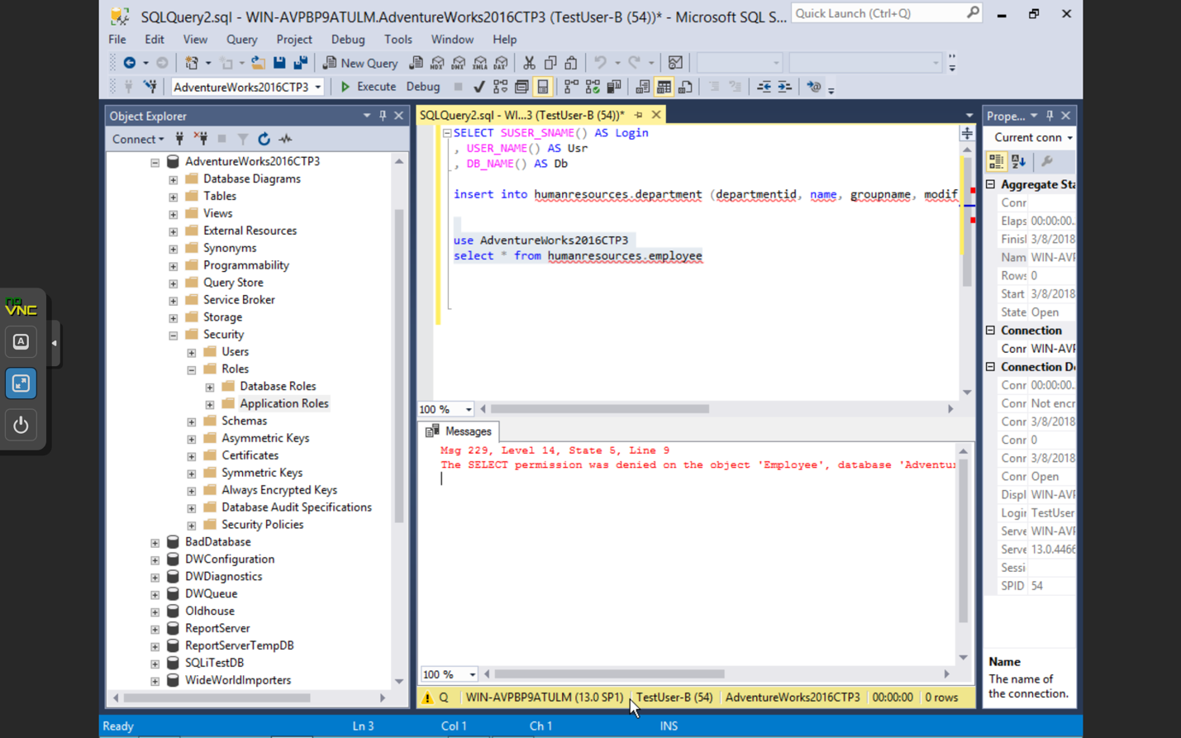

4) Does it work? Show the result in a screenshot. You have to click on Results to view the results. Describe your observation and explain why it works.

**Yes it worked because I enabled the application role for TestUser-B to be able to run a select query on the humanresources.employee table**

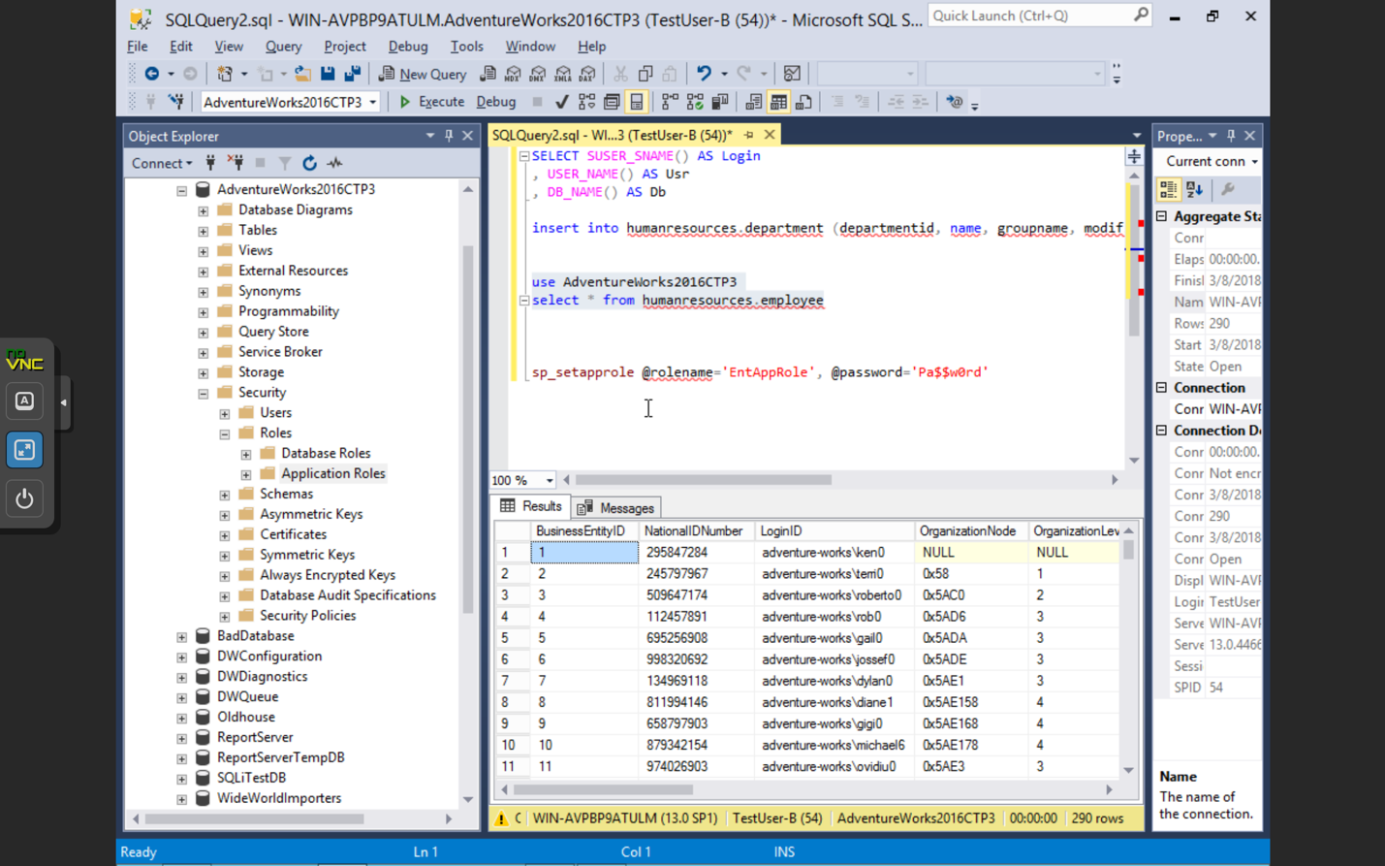

# Task #7. Assigning Permissions

9) Does it work? Show the result in a screenshot. Describe your observation and explain why it works.

**Yes because I granted permission for TestUser-A to select from person,address table.**

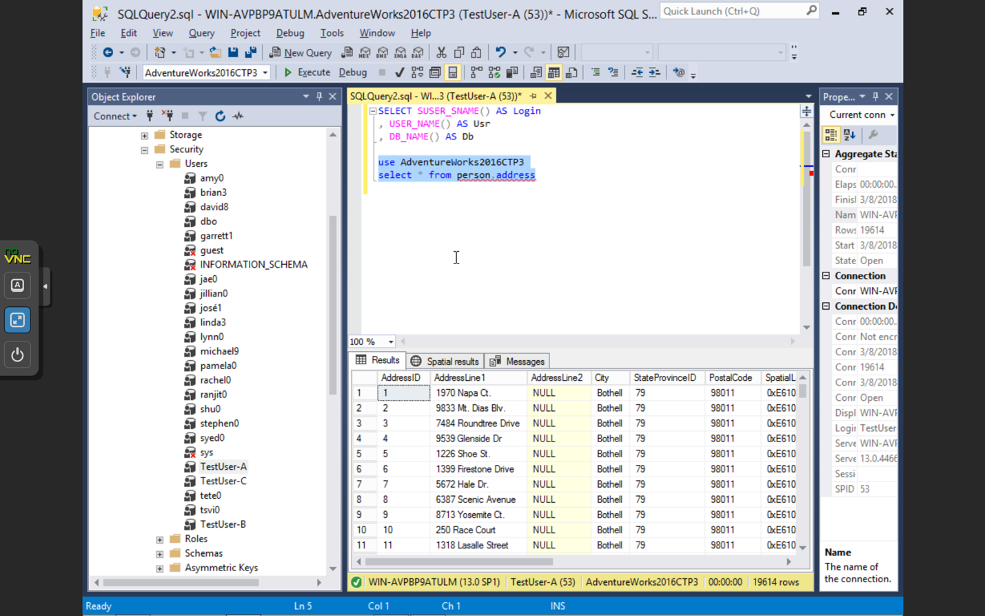

13) Run the previous query. Show the result in a screenshot. Describe your observation and explain why it fails.

**It fails because TestUser-A no longer has permissions to run select statements on person.address table.**

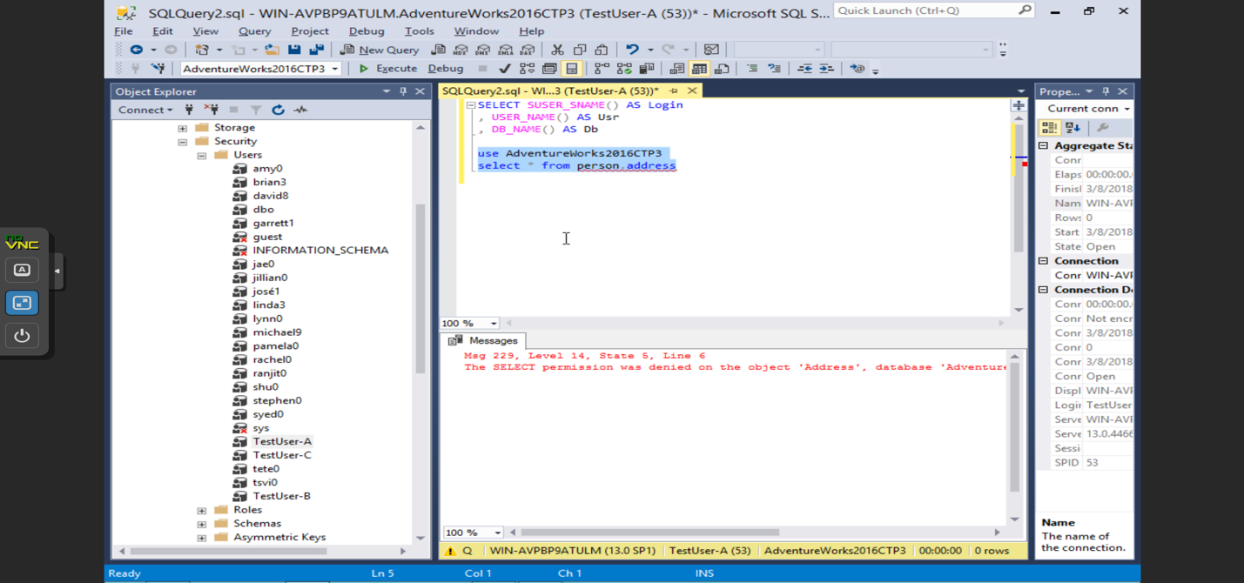

15) Run the previous query. Show the result in a screenshot. Describe your observation and explain why it works.

**It works because I gave TestUser-A the ability to read data or select data from this database.**



19) Run the previous query. Show the result in a screenshot. Describe your observation and explain why it fails.

**It fails because select statements are denied on the object Address.**

